# Module 4

**Unsupervised Learning and Generative Models in Keras**

**Generative Adversarial Networks (GANs) and TensorFlow**

## 📌 Generative Adversarial Networks (GANs)

Generative Adversarial Networks (GANs) are a class of neural network architectures designed to generate synthetic data that closely resembles real-world data.

They have become widely known for their ability to create realistic content such as images, music, and text.

### 🔹 Concept and Architecture

A GAN consists of two primary components:

* **Generator**: Receives a random noise vector as input and generates synthetic data (e.g., images). Its objective is to produce data that mimics real data as closely as possible.
* **Discriminator**: Receives both real data and synthetic data generated by the generator. It attempts to classify each input as real or fake. Its objective is to accurately distinguish between genuine and generated data samples.

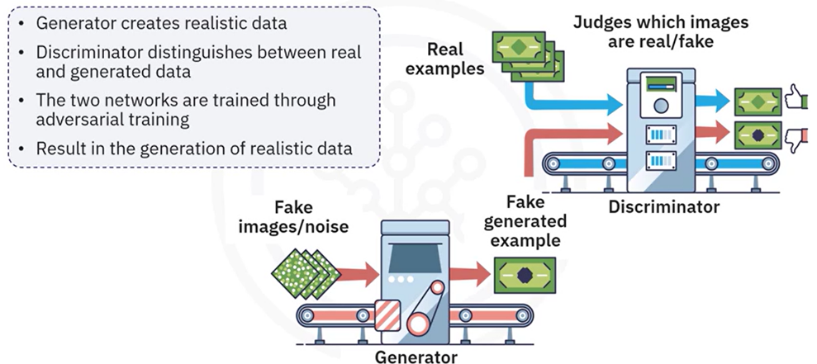

These two networks are trained simultaneously in an adversarial process where:

1. The **generator** is trained to fool the discriminator by creating realistic data.
2. The **discriminator** is trained to correctly identify real versus fake data.

This competition continues over multiple training cycles, pushing both networks to improve. Over time, the generator becomes so proficient that the discriminator can no longer reliably tell the difference between real and generated data.

**🔧** **Applications of GANs:**

GANs have enabled significant advances across various domains due to their generative capabilities:

* **Image Generation:** Create high-quality images from random noise inputs.
* **Image-to-Image Translation:** Convert images from one domain to another (e.g., transforming sketches into realistic photos).
* **Text-to-Image Synthesis:** Generate images based on textual descriptions.
* **Data Augmentation:** Produce synthetic samples to enrich training datasets and reduce overfitting.

### 🔹 Building a Basic GAN in Keras

The process of building a GAN in Keras involves creating the two individual models (generator and discriminator) and then combining them into a complete GAN framework.

**⚡ Building Process**

1. **Model Definitions**

**🔗 Generator model:**

Accepts a 100-dimensional noise vector as input.

Outputs a synthetic image (e.g., 28x28 pixels).

The architecture includes dense layers that map noise to the structured image data.

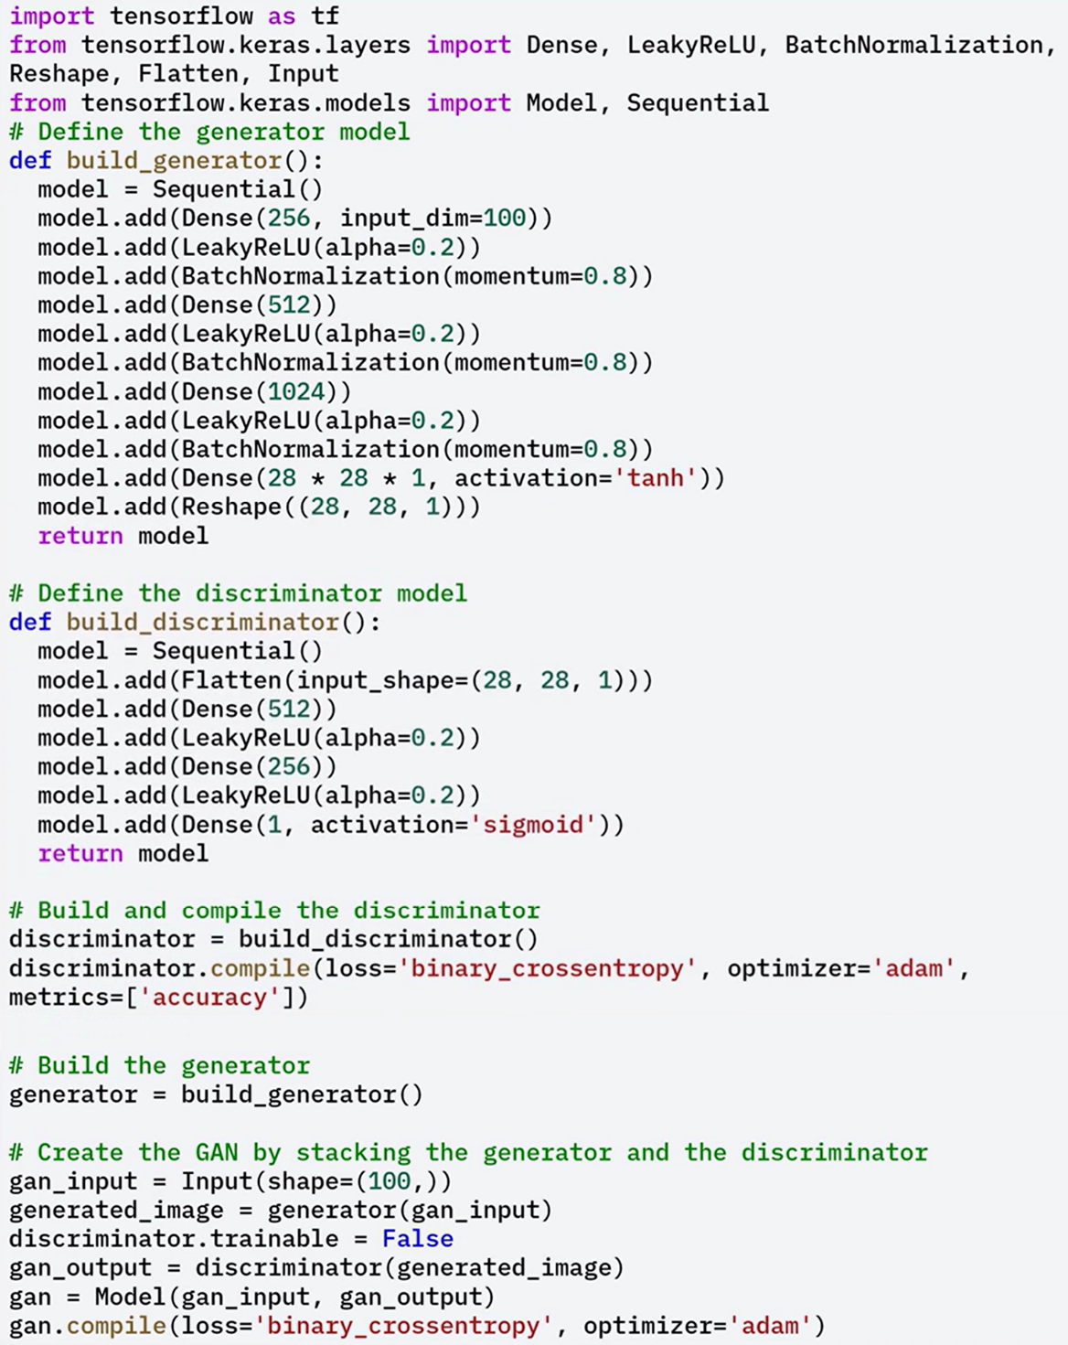

**🔗 Discriminator model:**

Accepts an image as input (real or generated).

Outputs a single probability score indicating whether the input is real or fake.

The architecture includes dense layers for classification.



1. **Combining into a GAN:**

A full GAN model is created by stacking the generator and discriminator.

During GAN compilation:

The discriminator is frozen (non-trainable) to ensure only the generator is updated when training the combined model.

This setup ensures that the generator learns to improve its outputs based solely on the discriminator’s feedback.



**⚡ Training Process**

Training a GAN involves alternating between updating the discriminator and the generator in each step of the training loop:

1. **Discriminator Training**:
   * A batch of real images is sampled from the dataset.
   * A batch of fake images is generated using the current generator.
   * The discriminator is trained to assign high confidence to real images and low confidence to generated ones.
2. **Generator Training**:
   * A new batch of noise vectors is passed through the generator.
   * These generated images are evaluated by the discriminator.
   * The generator is updated to improve its ability to fool the discriminator.

This adversarial cycle continues over many epochs, with the generator becoming increasingly adept at producing realistic images.

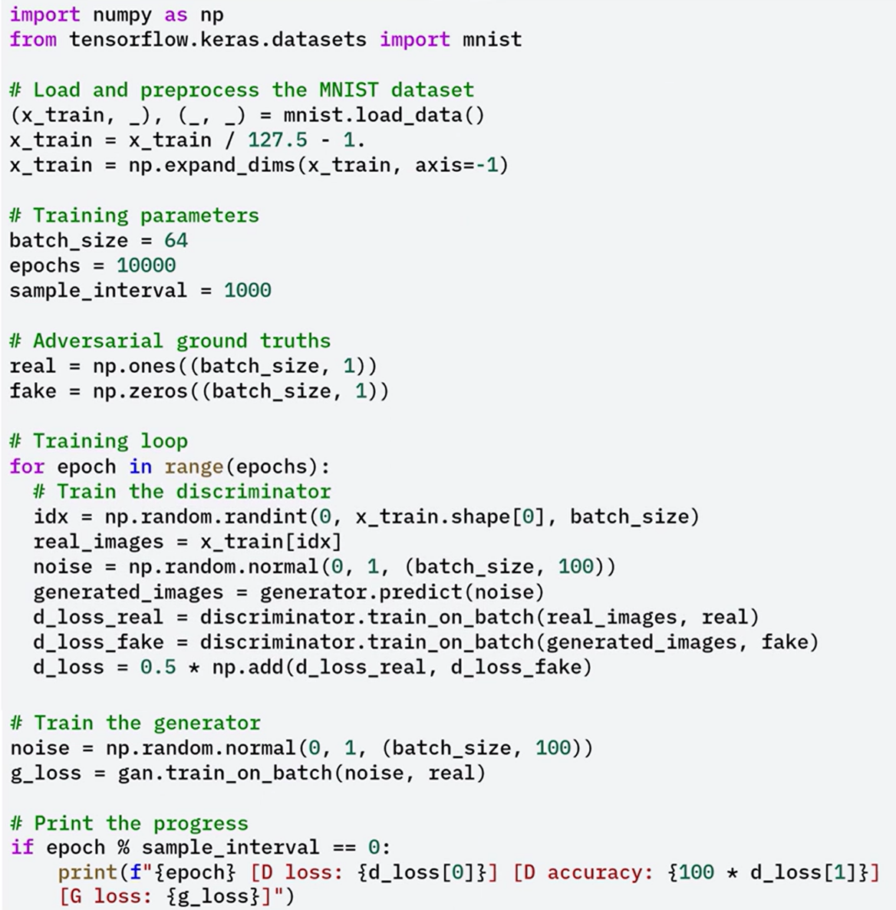

### 🔹 Evaluating the GAN

After training a GAN, it is essential to evaluate the quality and effectiveness of the synthetic data produced by the generator. A well-rounded evaluation combines both **qualitative inspection** and **quantitative metrics** to assess visual realism, statistical similarity, and training dynamics.

**🖼️ Qualitative Assessment: Visual Inspection**

Throughout the training process, the quality of generated images can be evaluated visually.

Visual inspection is the most immediate way to assess the output of a GAN. It involves manually reviewing the generated images using a function like sample_images to display a grid of outputs. The following criteria should be evaluated:

* **Clarity**: The images should be sharp, with clean edges and distinct shapes. Blurry images suggest the generator has not fully captured the underlying data distribution.
* **Coherence**: The generated images should have structural integrity that reflects the real data. For example, MNIST outputs should resemble legible digits with correct stroke patterns and contours.
* **Diversity**: The outputs should vary across the dataset. Lack of variation can indicate **mode collapse**, where the generator produces nearly identical outputs regardless of the input noise vector.

**Instructions for inspection:**

1. 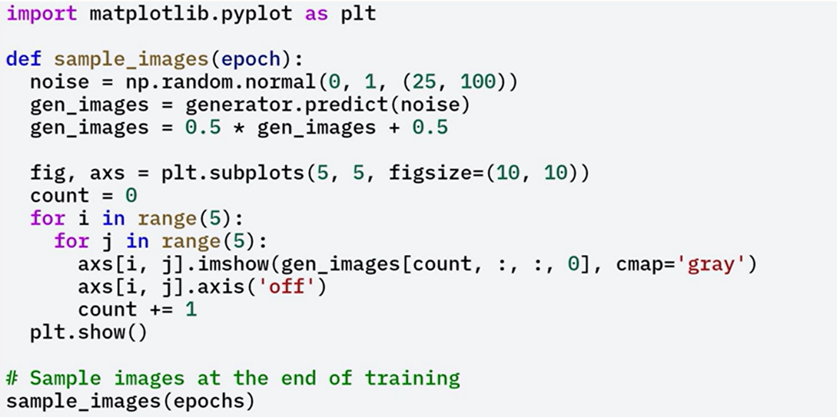Call the **sample_images** function after training to generate a 5x5 grid of synthetic images.
2. Review the grid visually for clarity, coherence, and diversity.
3. Use this process iteratively during training to detect degradation or improvement in generation quality.

Visual inspection provides fast, intuitive feedback but lacks objectivity. If quality issues are detected, consider tuning model architecture, learning rates, or batch size.

📏 **Quantitative Assessment: Metric**

While visual inspection offers immediate insight, it does not provide reproducible or statistically grounded metrics. Quantitative evaluations offer objective, measurable indicators of GAN performance:

* **Fréchet Inception Distance (FID)**: Measures the similarity between the distributions of real and generated images. It uses feature embeddings from a pre-trained network (e.g., Inception-V3) and computes the Fréchet distance between them. Lower scores indicate higher similarity and better performance.
* **Inception Score (IS)**: Evaluates both the clarity and diversity of generated images. Higher IS suggests that the images are recognizable and belong to distinct classes. IS is more suitable for complex datasets; it is less informative for datasets like MNIST.
* **Discriminator Accuracy**: During adversarial training, the ideal discriminator accuracy is around **50%**, indicating that the generator is producing images so realistic that the discriminator is uncertain. If accuracy is significantly higher or lower, it may suggest model imbalance or insufficient generator training.

In the provided code snippet, we calculate the discriminator accuracy on both the real and fake images.

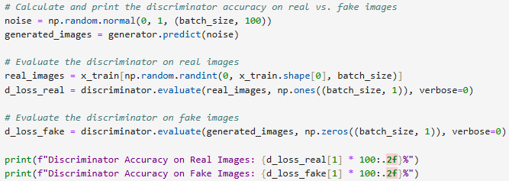

If the discriminator’s accuracy is around 50%, it implies the generator has learned to produce realistic images.

Higher or lower accuracy may suggest that either the generator is not producing convincing images, or the discriminator is overfitting.

🔁 **Combining Qualitative and Quantitative Evaluation**

For a robust GAN evaluation strategy, combine visual and metric-based assessments:

1. **Visual inspection**: Perform early and often to identify symptoms like blurry outputs, lack of structure, or mode collapse.
2. **Metric tracking**: Use FID or IS if working with more complex datasets. For MNIST or other simple datasets, discriminator accuracy provides meaningful feedback.
3. **Loss monitoring**: Plot generator and discriminator losses over time to assess convergence and stability. Irregular spikes or vanishing gradients indicate training imbalance.

### ✅ Takeaways

✅ GANs are powerful generative models composed of a generator and discriminator trained in opposition.

✅ The generator creates synthetic data from random noise, while the discriminator classifies data as real or fake.

✅ Through adversarial training, both models improve iteratively, resulting in highly realistic data generation.

✅ GANs are widely used in image synthesis, translation, and data augmentation tasks.

✅ In Keras, a basic GAN can be built by defining both models, combining them, and implementing an alternating training loop with adversarial objectives.

## 📌 TensorFlow for Unsupervised Learning

Unsupervised learning is a machine learning paradigm in which the model learns from data without any labeled responses or target outputs.

The objective is to uncover underlying patterns, groupings, or structures that are not explicitly provided.

TensorFlow offers robust tools to implement and scale unsupervised learning workflows across diverse applications.

Common unsupervised learning tasks include:

* **Clustering**: Grouping similar data points based on their feature similarity.
* **Dimensionality Reduction**: Compressing high-dimensional data into fewer dimensions while retaining key information.
* **Anomaly Detection**: Identifying data points that deviate significantly from the norm or distribution.

These techniques are widely applicable in domains such as customer segmentation, image compression, and fraud detection.

### 🔹 Building Clustering Models with TensorFlow

**Clustering Process in TensorFlow:**

1. **Data Preparation**:
   * Load the MNIST dataset.
   * Normalize pixel values to bring all features into a similar range.
   * Reshape the image data for compatibility with clustering models.
2. **K-Means Clustering**:
   * Apply the K-Means algorithm to the processed MNIST data.
   * Configure the algorithm to cluster the dataset into ten groups (representing the ten digits).
3. **Visualization**:
   * Display sample images from each cluster to visually assess the quality of clustering.
   * Groupings reveal how the algorithm identifies similar digit patterns.

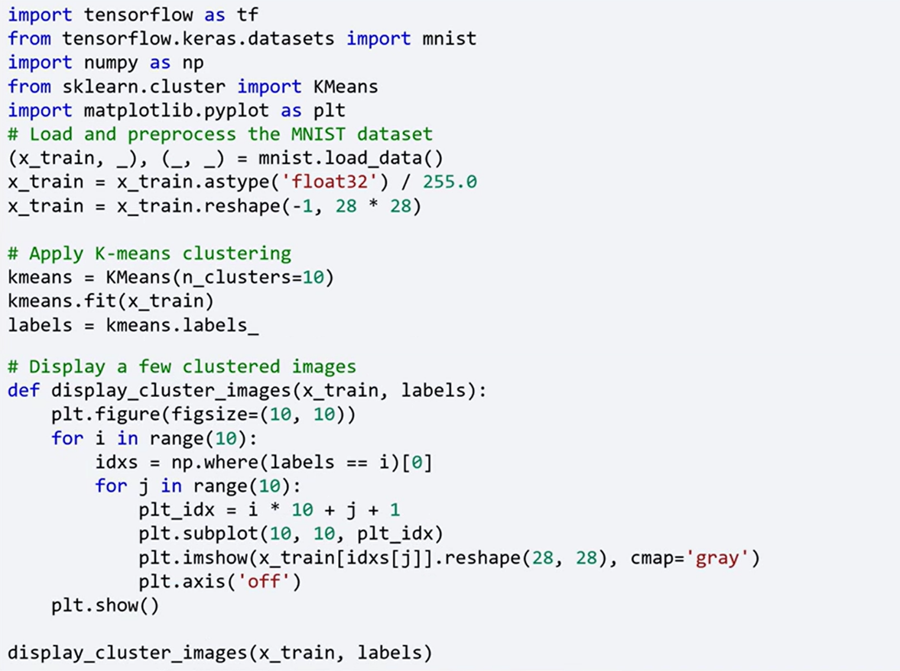

### 🔹 Dimensionality Reduction with Autoencoders

Dimensionality reduction is essential when dealing with high-dimensional datasets. Autoencoders are effective neural networks for this purpose. They compress input data into a lower-dimensional representation (bottleneck) and then reconstruct it to its original form.

**Autoencoder Architecture in TensorFlow:**

1. **Model Definition**:

* Input Layer: Accepts the original image data (e.g., 784-pixel MNIST vectors).
* Encoding Layer: Compresses the data to a smaller feature space.
* Bottleneck Layer: Captures the most essential information in a compact representation.
* Decoding Layer: Reconstructs the original data from the bottleneck.
* Output Layer: Produces a reconstruction of the input image.

1. **Training**:

* Train the autoencoder using the input data as both the input and the output.
* Minimize the reconstruction loss to ensure the learned representation retains essential structure.

1. **Evaluation and Visualization**:

* Extract the compressed features from the bottleneck layer after training.
* Apply **t-distributed Stochastic Neighbor Embedding (t-SNE)** to project these high-dimensional features into two dimensions.
* Plot the resulting 2D embeddings to visualize how the model separates and clusters the data in lower-dimensional space.

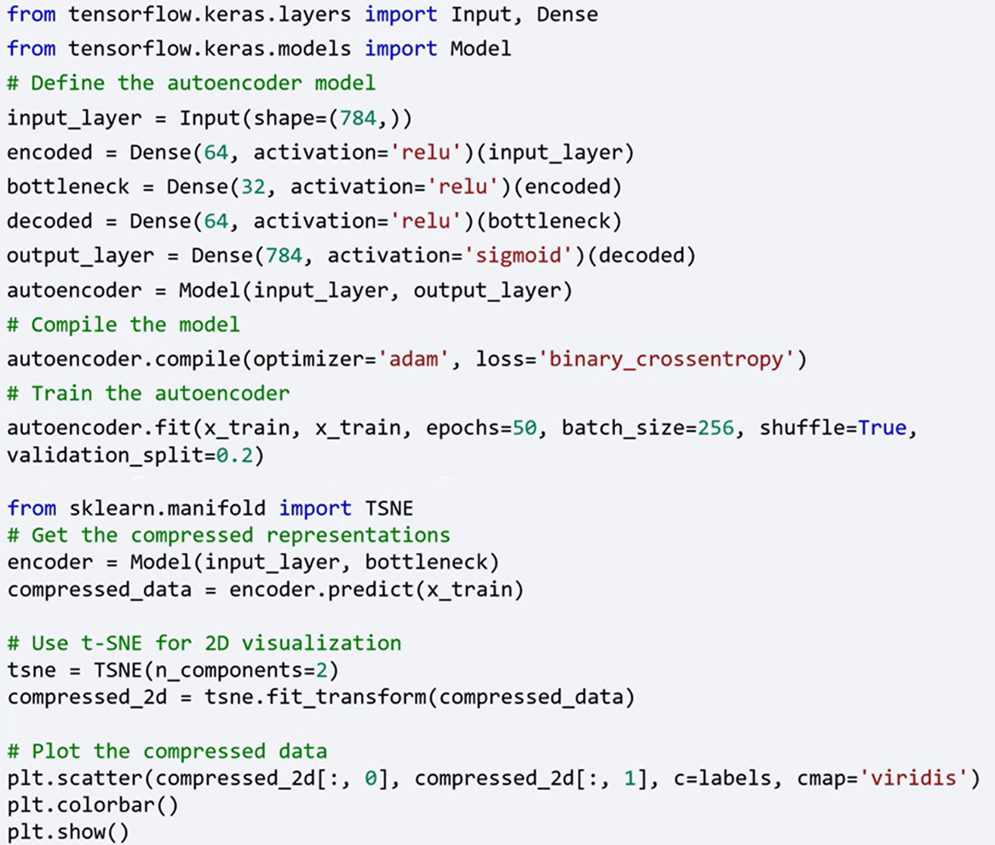



### ✅ Takeaways

✅ TensorFlow provides scalable and flexible tools for implementing unsupervised learning models.

✅ Unsupervised learning reveals hidden structures in unlabeled data and supports key tasks such as clustering, dimensionality reduction, and anomaly detection.

✅ Clustering with TensorFlow (e.g., using K-Means) enables automatic grouping of similar instances from complex datasets.

✅ Autoencoders in TensorFlow effectively reduce data dimensionality by learning compressed representations that retain essential features.

✅ Visualizations such as t-SNE plots allow inspection of how well the autoencoder clusters similar data in lower dimensions.